Nama : Helfanza Nanda Alfara

Kelas : 6A/16090026

Usability testing

**SISTEM INFORMASI HIMAPRODI TI**

1. **White Box**
2. FlowChart
3. Admin

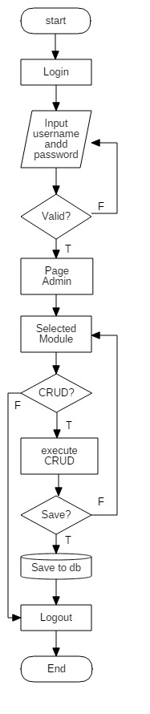

1. User

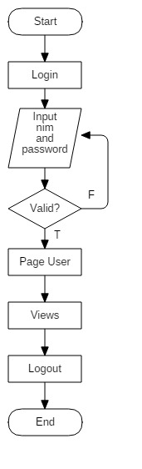

1. CFG(Control Flow Graph)
2. Admin II. User

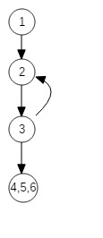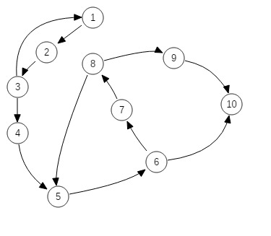

1. Cyclomatic Complexity

Rumus = *Decision* + 1

* Admin

3 + 1 = 4

* User

1 + 1 = 2

1. Basic Path

* Admin

1. : 1-2-3-4-5-6-7-8-9-10
2. : 1-2-3-1-2-3-4-5-6-7-8-9-10
3. : 1-2-3-4-5-6-7-8-5-6-7-8-9-10
4. : 1-2-3-4-5-6-10

* User

1. : 1-2-3-4-5-6
2. : 1-2-3-2-3-4-5-6
3. **Black Box**

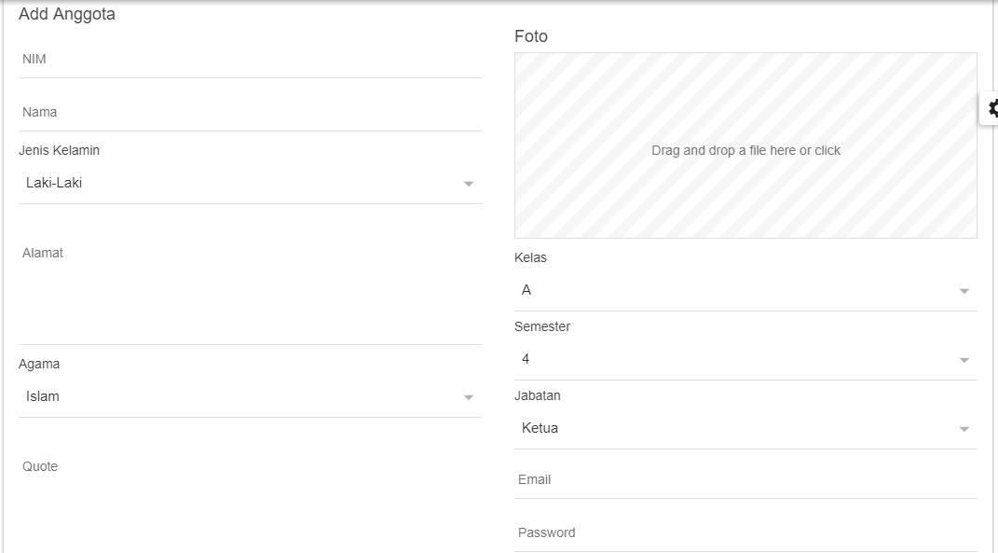

form tambah anggota



Form edit Anggota

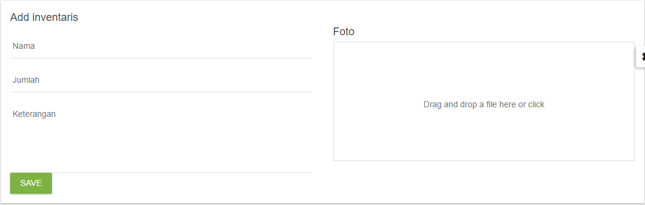

Form tambah inventaris

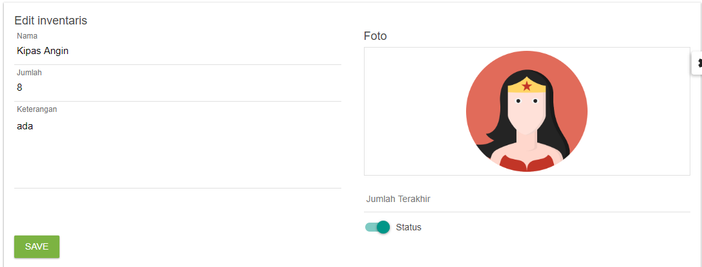

Form edit inventaris

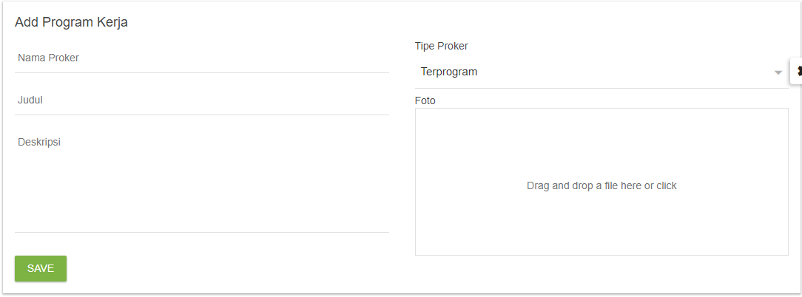

Form tambah program kerja

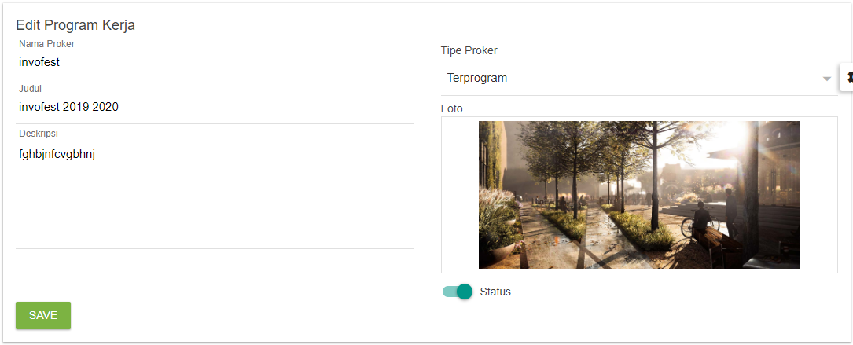

Form edit program kerja

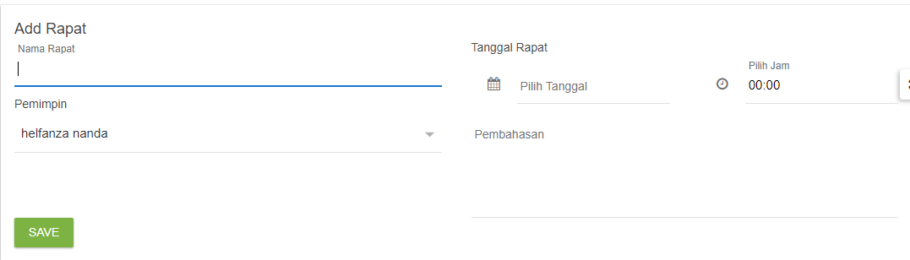

Form tambah rapat

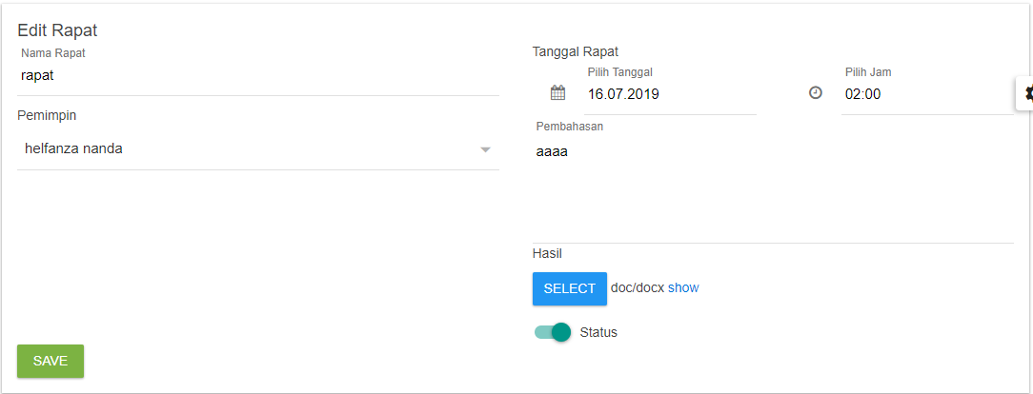

Form edit rapat

1. Equivslence Partitioning
2. Modul anggota

* Validasi untuk nim

|  |  |  |
| --- | --- | --- |
| Invalid | Valid | Invalid |
| …,6,7 | 8 | 9,10,…. |

* Validasi untuk nama

|  |  |  |
| --- | --- | --- |
| Invalid | Valid | Invalid |
| …-1,0 | 1,2,3,…50 | 51,52,… |

* Validasi untuk alamat

|  |  |  |
| --- | --- | --- |
| Invalid | Valid | Invalid |
| …-1,0 | 1,2,3,…100 | 101,102,… |

* Validasi untuk email

|  |  |  |
| --- | --- | --- |
| Invalid | Valid | Invalid |
| …-1,0 | 1,2,3,…50 | 51,52,… |

* Validasi untuk password

|  |  |  |
| --- | --- | --- |
| Invalid | Valid | Invalid |
| …,6,7 | 8 | 9,10,…. |

* Validasi untuk gambar(dalam mb)

|  |  |  |
| --- | --- | --- |
| Invalid | Valid | Invalid |
| …,-1,0 | 1,2 | 3,4…. |

1. Modul Inventaris

* Validasi untuk nama inventaris

|  |  |  |
| --- | --- | --- |
| Invalid | Valid | Invalid |
| …,-1,0 | 1,2,3,...50 | 51,52,…. |

* Validasi untuk jumlah (length integer)

|  |  |  |
| --- | --- | --- |
| Invalid | Valid | Invalid |
| …-1,0 | 1,2,3 | 4,5,…. |

* Validasi untuk keterangan

|  |  |  |
| --- | --- | --- |
| Invalid | Valid | Invalid |
| …,-1,0 | 1,2,3,…100 | 101,102,…. |

* Validasi untuk gambar(dalam mb)

|  |  |  |
| --- | --- | --- |
| Invalid | Valid | Invalid |
| …,-1,0 | 1,2 | 3,4…. |

1. Modul Program Kerja

* Validasi untuk nama proker

|  |  |  |
| --- | --- | --- |
| Invalid | Valid | Invalid |
| …,-1,0 | 1,2,3,...50 | 51,52,…. |

* Validasi untuk judul

|  |  |  |
| --- | --- | --- |
| Invalid | Valid | Invalid |
| …-1,0 | 1,2,3,…, 100 | 101,102,…. |

* Validasi untuk deskripsi

|  |  |  |
| --- | --- | --- |
| Invalid | Valid | Invalid |
| …,-1,0 | 1,2,3,…100 | 101,102,…. |

* Validasi untuk foto(dalam mb)

|  |  |  |
| --- | --- | --- |
| Invalid | Valid | Invalid |
| …,-1,0 | 1,2 | 3,4…. |

1. Modul Rapat

* Validasi untuk nama rapat

|  |  |  |
| --- | --- | --- |
| Invalid | Valid | Invalid |
| …,-1,0 | 1,2,3,...50 | 51,52,…. |

* Validasi untuk nama pembahasan rapat

|  |  |  |
| --- | --- | --- |
| Invalid | Valid | Invalid |
| …,-1,0 | 1,2,3,...255 | 256,257,…. |

* Validasi untuk tanggal rapat

|  |  |  |
| --- | --- | --- |
| Invalid | Valid | Invalid |
| …,-1,0 | 1,2,3,...31 | 31,32,…. |

* Validasi untuk jam rapat

|  |  |  |
| --- | --- | --- |
| Invalid | Valid | Invalid |
| …,07.58,07.59 | 08.00,09.00,..,17.00 | 17.01,17.02 ,…. |

1. Tabel Kebenaran

(*) F Tebal / **F**  = **Error**, T Tebal/ **T = Berhasil**

* Validasi Untuk login admin dan login anggota

|  |  |  |  |  |
| --- | --- | --- | --- | --- |
| Email | F | F | T | T |
| Password | F | T | F | T |
|  | error | Error | error | Berhasil |

* Validasi Untuk Tambah Anggota (admin)

Kenapa dari agama sampai semester jika bernilai false tapi hasilnya berhasil, karena sudah memliki nilai default, memakai combo box,

|  |  |  |  |  |  |  |  |  |  |  |  |
| --- | --- | --- | --- | --- | --- | --- | --- | --- | --- | --- | --- |
| Nim | T | T | T | T | T | T | T | T | T | T | T |
| Nama | T | T | T | T | T | T | T | T | T | T | - |
| Alamat | T | T | T | T | T | T | T | T | T | - | - |
| Quote | T | T | T | T | T | T | T | T | - | - | - |
| Email | T | T | T | T | T | T | T | - | - | - | - |
| Password | T | T | T | T | T | T | - | - | - | - | - |
| Foto | T | T | T | T | T | - | - | - | - | - | - |
| Agama | T | T | T | T | F | - | - | - | - | - | - |
| Jabatan | T | T | T | F | F | - | - | - | - |  | - |
| Kelas | T | T | F | F | F | - | - | - | - | - | - |
| Semester | T | F | F | F | F | - | - | - | - | - | - |
|  | **T** | **T** | **T** | **T** | **T** | **F** | **F** | **F** | **F** | **F** | **F** |

* Validasi Untuk Edit Anggota (admin)

Kenapa dari agama sampai semester jika bernilai false tapi hasilnya berhasil, karena sudah memliki nilai default, memakai combo box, dan kalau foto, jika False hasilnya berhasil karena di edit foto yang dulu masih disimpan, jadi jika foto tidak diisi maka masih memakai foto yang lama

|  |  |  |  |  |  |  |  |  |  |  |  |
| --- | --- | --- | --- | --- | --- | --- | --- | --- | --- | --- | --- |
| Nim | T | T | T | T | T | T | T | T | T | T | T |
| Nama | T | T | T | T | T | T | T | T | T | T | - |
| Alamat | T | T | T | T | T | T | T | T | T | - | - |
| Quote | T | T | T | T | T | T | T | T | - | - | - |
| Email | T | T | T | T | T | T | T | - | - | - | - |
| Password | T | T | T | T | T | T | - | - | - | - | - |
| Foto | T | T | T | T | T | F | - | - | - | - | - |
| Agama | T | T | T | T | F | F | - | - | - | - | - |
| Jabatan | T | T | T | F | F | F | - | - | - |  | - |
| Kelas | T | T | F | F | F | F | - | - | - | - | - |
| Semester | T | F | F | F | F | F | - | - | - | - | - |
|  | **T** | **T** | **T** | **T** | **T** | **T** | **F** | **F** | **F** | **F** | **F** |

* Validasi Untuk Tambah Inventaris (admin)

|  |  |  |  |  |
| --- | --- | --- | --- | --- |
| Nama_inv | Jumlah | Keterangan | Foto |  |
| T | T | T | T | Berhasil |
| T | T | T | F | Error |
| T | T | - | - | Error |
| T | - | - | - | Error |

* Validasi Untuk Edit Inventaris (admin)

Status jika false maka berhasil karena sudah memilki default, begitu pun foto

|  |  |  |  |  |  |  |
| --- | --- | --- | --- | --- | --- | --- |
| Nama_inv | Jumlah | Keterangan | Jumlah terakhit | Status | foto |  |
| T | T | T | T | T | T | Berhasil |
| T | T | T | T | F | F | Berhasil |
| T | T | T | T | - | - | Error |
| T | T | T | - | - | - | Error |
| T | T | - | - | - | - | Error |
| T | - | - | - | - | - | Error |

* Validasi Untuk Tambah Program Kerja (admin)

|  |  |  |  |  |
| --- | --- | --- | --- | --- |
| Nama_Proker | Judul | Deskripsi | Foto |  |
| T | T | T | T | Berhasil |
| T | T | T | F | Error |
| T | T | - | - | Error |
| T | - | - | - | Error |

* Validasi Untuk Edit Program Kerja (admin)

Status jika false maka berhasil karena sudah memilki default, begitu pun foto

|  |  |  |  |  |  |
| --- | --- | --- | --- | --- | --- |
| Nama_Proker | Judul | Deskripsi | Foto | Status |  |
| T | T | T | T | T | Berhasil |
| T | T | T | F | F | Berhasil |
| T | T | T | - | - | Error |
| T | T | - | - | - | Error |
| T | - | - | - | - | Error |

* Validasi Untuk Tambah Rapat (admin)

|  |  |  |  |  |  |
| --- | --- | --- | --- | --- | --- |
| Nama_Rapat | Tanggal | Pembahasan | Pemimpin | Jam |  |
| T | T | T | T | T | Berhasil |
| T | T | T | T | - | Error |
| T | T | T | - | - | Error |
| T | T | - | - | - | Error |
| T | - | - | - | - | Error |

* Validasi Untuk edit Rapat (admin)

Status jika false maka berhasil karena sudah memilki default,

|  |  |  |  |  |  |  |
| --- | --- | --- | --- | --- | --- | --- |
| Nama_Rapat | Tanggal | Pembahasan | Pemimpin | Jam | Status |  |
| T | T | T | T | T | T | Berhasil |
| T | T | T | T | T | F | Berhasil |
| T | T | T | T | - | - | Error |
| T | T | T | - | - | - | Error |
| T | T | - | - | - | - | Error |
| T | - | - | - | - | - | Error |